Praktikum week 11

Nama : Ummu Izzatul Kharimah

NIM : 41122210009

1. Get All data

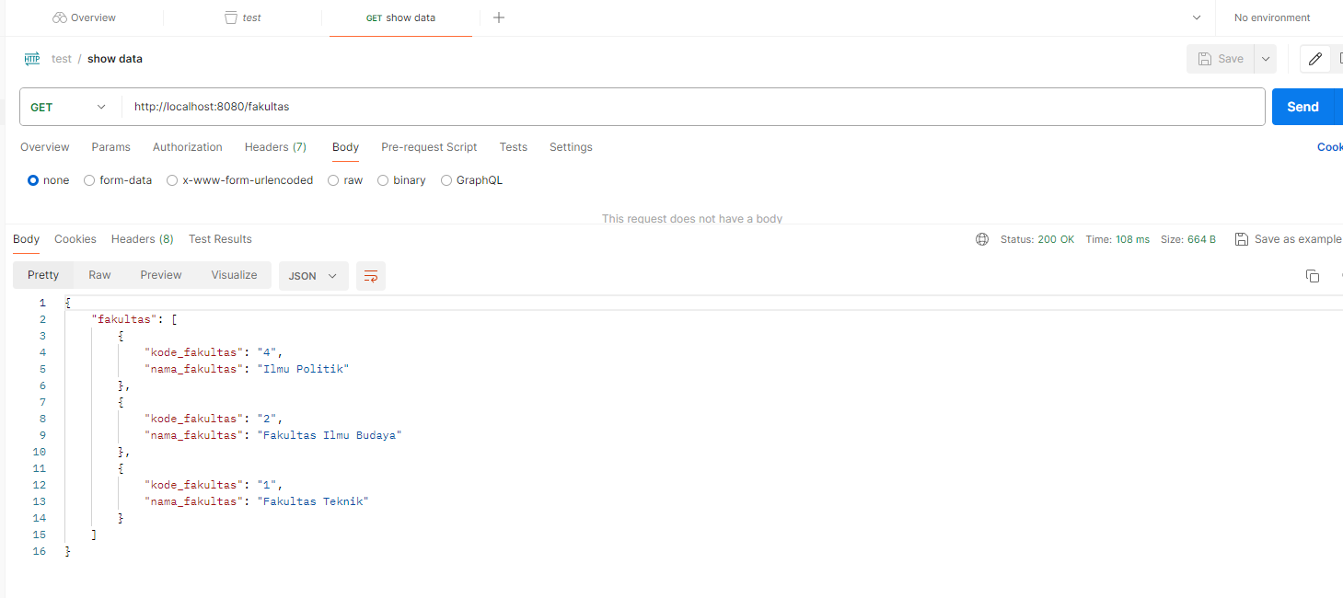

2. Get detail data

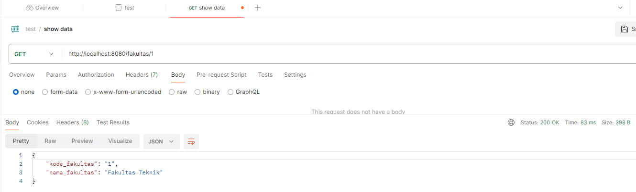

3. Create new data

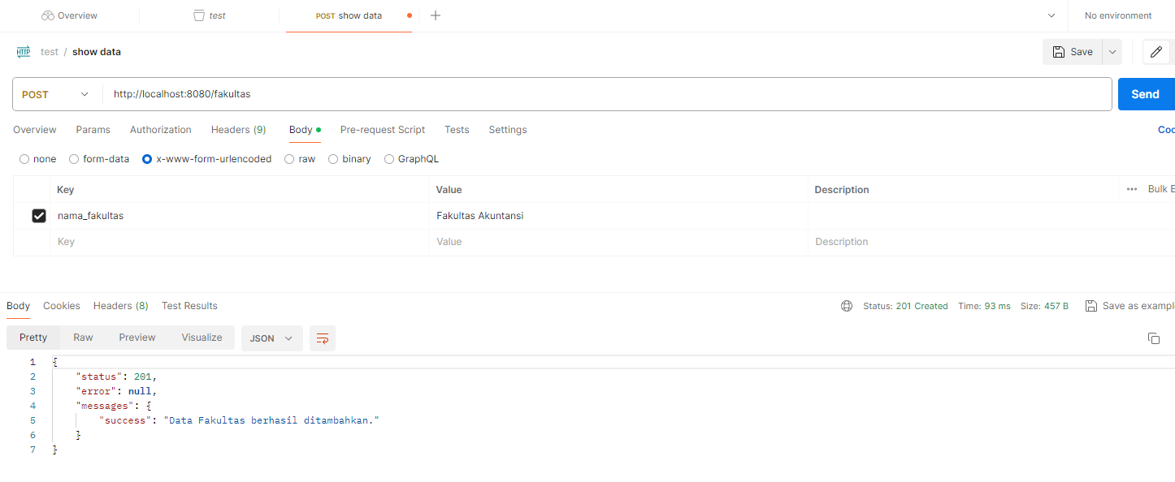

4. Update existing data

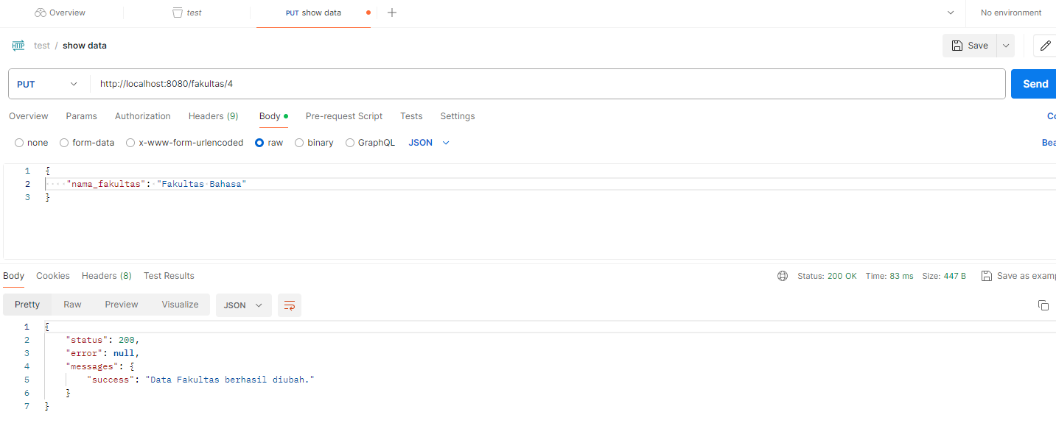

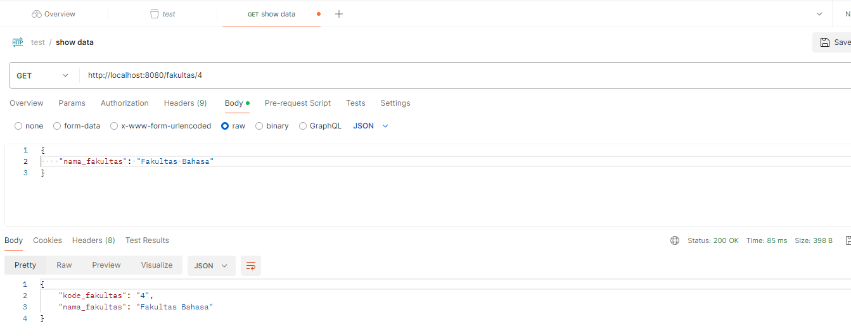

5. Delete data

